Ex.no:4a | EXPLORATORY DATA ANALYSIS (EDA) – DATA INSPECTION, FILTERING, STATISTICAL ANALYSIS AND CORRELATION
Date:

Aim:
To perform data inspection, filtering, grouping, aggregation, descriptive statistical analysis, and correlation analysis on sales dataset using Pandas and visualize the results using Matplotlib.

Algorithm:
1. Import the required Pandas, NumPy and Matplotlib libraries.
2. Read the Sales-Data-Analysis.csv file using Pandas.
3. Display the dataset and inspect the first few records.
4. Find the number of rows and columns and display the data types.
5. Generate the statistical summary of the dataset.
6. Filter sales records based on Total Sales and Quantity conditions.
7. Sort sales records based on Price and Total Sales.
8. Group the data based on Product and City to calculate average Total Sales and Quantity.
9. Calculate mean, median, minimum, maximum and standard deviation of Total Sales.
10. Calculate the correlation between Price, Quantity, and Total Sales.
11. Create bar chart, line chart, scatter plot, histogram and box plot using Matplotlib.
12. Display the results and interpret the obtained data.

Program:
# Import libraries
import pandas as pd
import numpy as np
import matplotlib.pyplot as plt

# Read dataset
df = pd.read_csv('Sales-Data-Analysis.csv')
df['Total Sales'] = df['Price'] * df['Quantity']

# Display dataset
print(df)

# Display first five records
print(df.head())

# Display shape
print(df.shape)

# Display data types
print(df.dtypes)

# Display statistical summary
print(df.describe())

# Filter sales with Total Sales greater than 5000
print(df[df['Total Sales'] > 5000])

# Filter sales with Quantity greater than 500
print(df[df['Quantity'] > 500])

# Sort sales by Total Sales
print(df.sort_values('Total Sales', ascending=False))

# Product-wise average Total Sales
print(df.groupby('Product')['Total Sales'].mean())

# City-wise average Total Sales
print(df.groupby('City')['Total Sales'].mean())

# Calculate mean
print('Mean Total Sales:', df['Total Sales'].mean())

# Calculate median
print('Median Total Sales:', df['Total Sales'].median())

# Calculate minimum
print('Minimum Total Sales:', df['Total Sales'].min())

# Calculate maximum
print('Maximum Total Sales:', df['Total Sales'].max())

# Calculate standard deviation
print('Standard Deviation:', df['Total Sales'].std())

# Display correlation matrix
print(df[['Price', 'Quantity', 'Total Sales']].corr())

# Display correlation between Price and Quantity
print('Correlation:', df['Price'].corr(df['Quantity']))

# Bar chart
prod_agg = df.groupby('Product')['Total Sales'].sum()
plt.bar(prod_agg.index, prod_agg.values)
plt.title('Total Sales by Product')
plt.xlabel('Product')
plt.ylabel('Total Sales ($)')
plt.show()

# Line chart
df['Date_dt'] = pd.to_datetime(df['Date'], format='%d-%m-%Y')
daily_sales = df.groupby('Date_dt')['Total Sales'].sum().sort_index()
plt.plot(daily_sales.index, daily_sales.values, marker='o')
plt.title('Sales Trend Over Time')
plt.xlabel('Date')
plt.ylabel('Total Sales ($)')
plt.show()

# Scatter plot
plt.scatter(df['Quantity'], df['Total Sales'])
plt.title('Total Sales vs Quantity')
plt.xlabel('Quantity')
plt.ylabel('Total Sales ($)')
plt.show()

# Histogram
plt.hist(df['Total Sales'], bins=10)
plt.title('Total Sales Distribution')
plt.xlabel('Total Sales ($)')
plt.ylabel('Frequency')
plt.show()

# Box plot
plt.boxplot(df['Total Sales'])
plt.title('Total Sales Box Plot')
plt.ylabel('Total Sales ($)')
plt.show()

Output:
1. First 5 Records (df.head()):
Order ID | Date | Product | Price | Quantity | Purchase Type | Payment Method | Manager | City | Total Sales | Date_dt
10452 | 07-11-2022 | Fries | 3.49 | 573.07 | Online | Gift Card | Tom Jackson | London | 2000.01 | 2022-11-07 00:00:00
10453 | 07-11-2022 | Beverages | 2.95 | 745.76 | Online | Gift Card | Pablo Perez | Madrid | 2199.99 | 2022-11-07 00:00:00
10454 | 07-11-2022 | Sides & Other | 4.99 | 200.40 | In-store | Gift Card | Joao Silva | Lisbon | 1000.00 | 2022-11-07 00:00:00
10455 | 08-11-2022 | Burgers | 12.99 | 569.67 | In-store | Credit Card | Walter Muller | Berlin | 7400.01 | 2022-11-08 00:00:00
10456 | 08-11-2022 | Chicken Sandwiches | 9.95 | 201.01 | In-store | Credit Card | Walter Muller | Berlin | 2000.05 | 2022-11-08 00:00:00
Shape: (254, 11)
Data Types:
Order ID int64
Date object
Product object
Price float64
Quantity float64
Purchase Type object
Payment Method object
Manager object
City object
Total Sales float64
Date_dt datetime64[ns]
2. Statistical Summary (df.describe()):
index | Order ID | Price | Quantity | Total Sales | Date_dt
count | 254.00 | 254.00 | 254.00 | 254.00 | 254
mean | 10584.13 | 7.10 | 460.61 | 3029.59 | 2022-12-03 10:23:37.322834688
min | 10452.00 | 2.95 | 200.40 | 1000.00 | 2022-11-07 00:00:00
25% | 10520.25 | 3.49 | 201.01 | 2000.01 | 2022-11-21 00:00:00
50% | 10583.50 | 4.99 | 538.88 | 2100.02 | 2022-12-03 00:00:00
75% | 10649.75 | 9.95 | 677.44 | 2400.00 | 2022-12-16 18:00:00
max | 10713.00 | 29.05 | 754.43 | 16074.43 | 2022-12-29 00:00:00
std | 75.89 | 4.34 | 214.89 | 2420.12 | nan
3. Filtered Records (Total Sales > 5000 - Sample):
Order ID | Date | Product | Price | Quantity | Purchase Type | Payment Method | Manager | City | Total Sales | Date_dt
10455 | 08-11-2022 | Burgers | 12.99 | 569.67 | In-store | Credit Card | Walter Muller | Berlin | 7400.01 | 2022-11-08 00:00:00
10460 | 09-11-2022 | Burgers | 12.99 | 554.27 | In-store | Credit Card | Remy Monet | Paris | 7199.97 | 2022-11-09 00:00:00
10465 | 10-11-2022 | Burgers | 12.99 | 554.27 | In-store | Credit Card | Pablo Perez | Madrid | 7199.97 | 2022-11-10 00:00:00
10470 | 11-11-2022 | Burgers | 12.99 | 554.27 | In-store | Credit Card | Pablo Perez | Madrid | 7199.97 | 2022-11-11 00:00:00
10475 | 12-11-2022 | Burgers | 12.99 | 523.48 | In-store | Credit Card | Pablo Perez | Madrid | 6800.01 | 2022-11-12 00:00:00

4. Department/Product-wise Average Sales:
Product | Price | Quantity | Total Sales
Beverages | 2.95 | 699.66 | 2064.01
Burgers | 12.99 | 558.12 | 7250.00
Chicken Sandwiches | 10.32 | 214.15 | 2204.65
Fries | 3.92 | 628.12 | 2464.20
Sides & Other | 4.99 | 200.40 | 1000.00
Mean Total Sales: 3029.59
Median Total Sales: 2100.02
Minimum Total Sales: 1000.00
Maximum Total Sales: 16074.43
Standard Deviation: 2420.12
Correlation Matrix:
Price Quantity Total Sales
Price 1.000000 -0.260207 0.761883
Quantity -0.260207 1.000000 0.348593
Total Sales 0.761883 0.348593 1.000000
Correlation (Price vs Quantity): -0.260207
Visualizations:
• Total Sales by Product

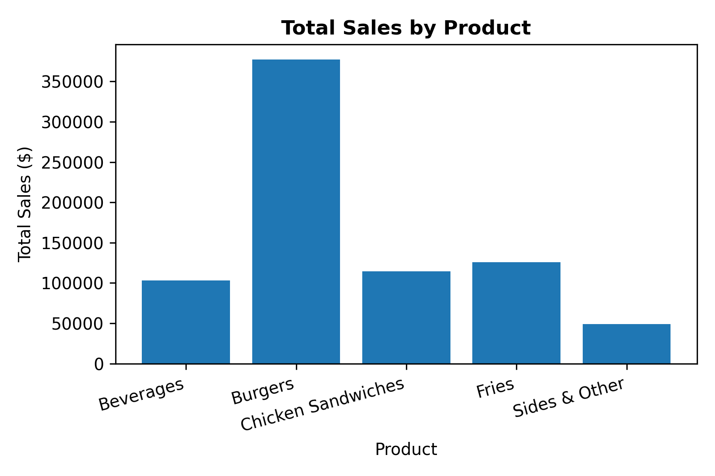
• Sales Trend Over Time

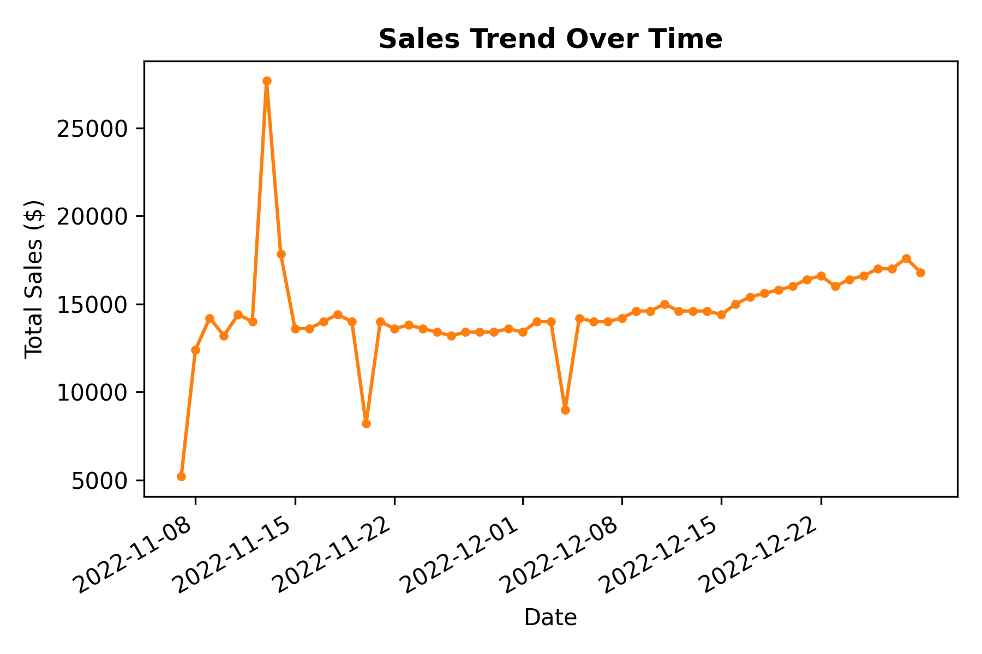
• Total Sales vs Quantity

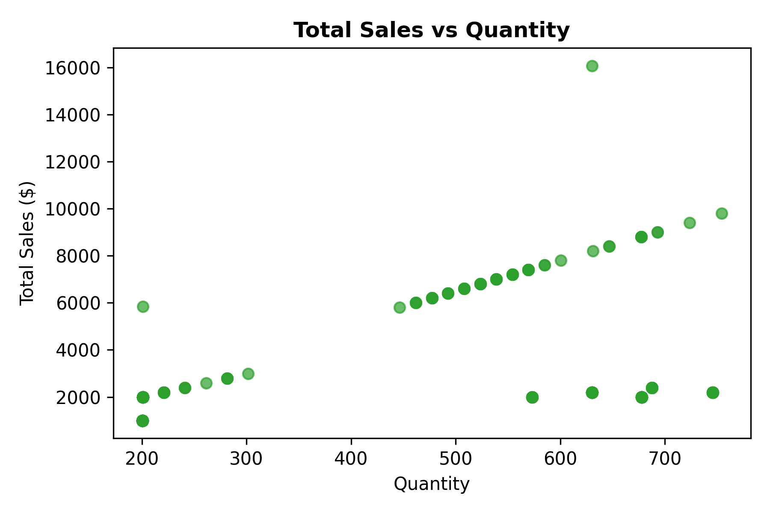
• Total Sales Distribution

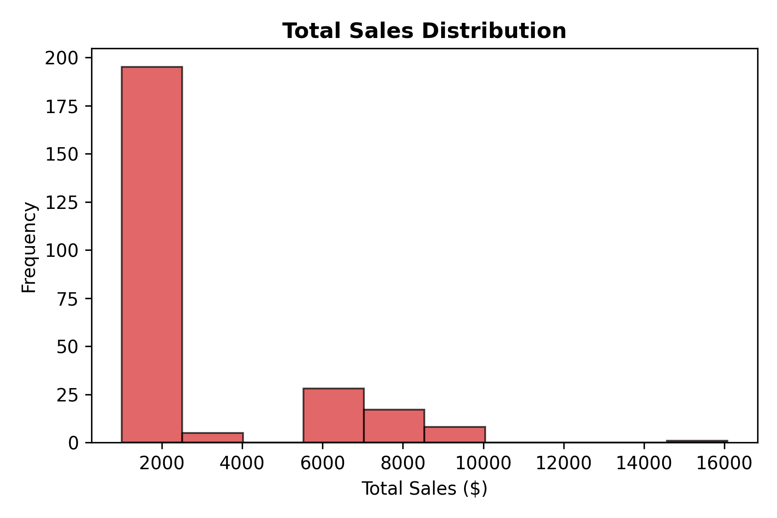
• Total Sales Box Plot

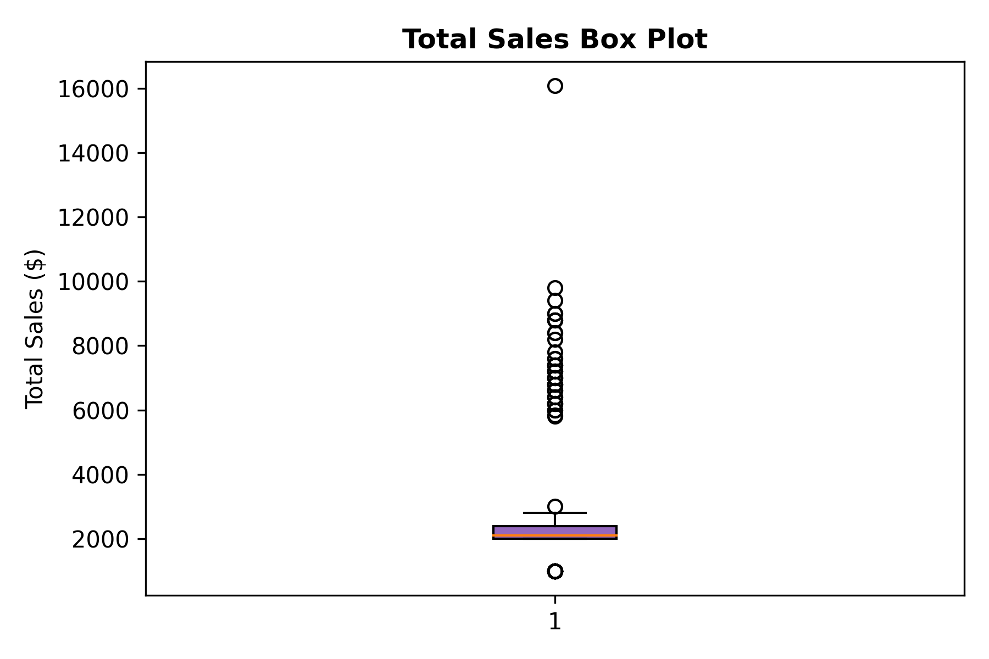
Result:

